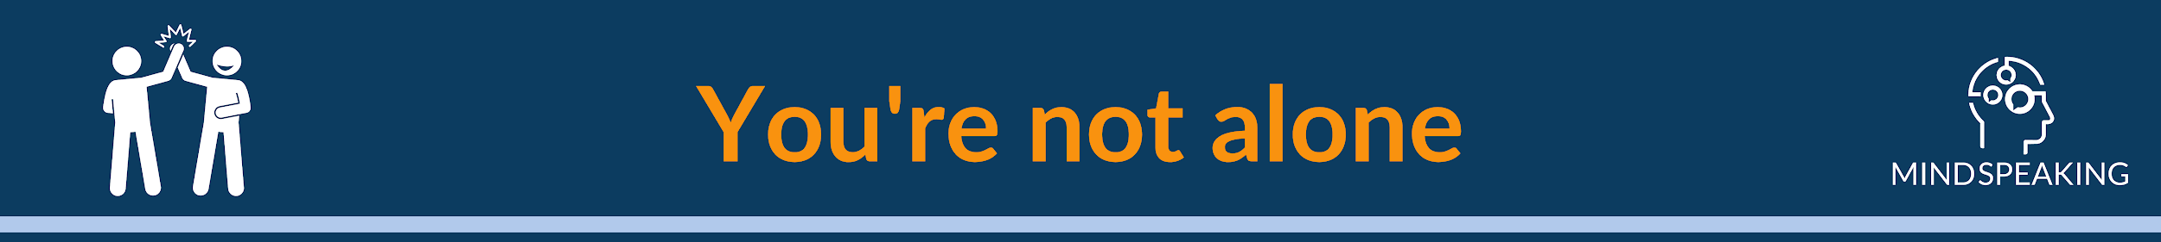

## **Buddy system**

﻿﻿In this course, we help you to find a **buddy**.

**Benefits:**

* You keep each other accountable
* You can give feedback to each other
* You learn from fellow Data professionals
* You're building a network  
   ﻿﻿

﻿﻿[Click here to find your buddy!](https://docs.google.com/spreadsheets/d/1RbayLLjCsR1U__B6GIBhJbMyy0a_f0A3fi_znVUCoiI/edit?pli=1#gid=0) It's simple.  
﻿﻿  
  
﻿﻿

﻿﻿